Strategic Website Design for Business Growth
Md Mehedi Hasan Polash ¹, Tridib Sarkar ², Md Rabiul Islam Asif ³, Afsar Mahbub Khan ⁴, Md Saidul Islam ⁵
Computer Science and Engineering Department
American International University-Bangladesh
Dhaka, Bangladesh
¹ 22-46566-1@student.aiub.edu
² 22-46444-1@student.aiub.edu
³ 22-48011-2@student.aiub.edu
⁴ 22-49366-3@student.aiub.edu
⁵ 22-49719-3@student.aiub.edu

Abstract—This report explores the role of strategic website design in driving business growth by enhancing user engagement and improving online presence. The objective was to analyse how design elements like user-friendly interfaces, responsive layouts, and SEO-optimized content contribute to better customer experiences and increased conversions. A survey was conducted to gather insights from users and business owners on the impact of well-designed websites. The findings indicate that incorporating strategic design features significantly boosts customer satisfaction and business performance. Suggested improvements include integrating analytics tools, e-commerce functionality, and mobile optimization to maximize the potential of business websites.

Index Terms— Website design, user experience, SEO, business growth, responsive design.
- Introduction
  - Background Information

In today’s digital era, having a strong online presence is essential for businesses to grow and thrive. A well-designed website serves as the foundation for this presence, acting as the primary platform for customer engagement, brand representation, and online transactions. Many businesses, especially small and medium enterprises, face challenges in creating effective websites that align with their goals and cater to their target audience. Poor design, lack of responsiveness, and absence of optimization often result in lost opportunities and reduced growth potential. Addressing these issues with strategic website design can significantly enhance customer experience and drive business success.

  - Overview of the Report

This report explores the role of strategic website design in fostering business growth. It highlights the importance of key design elements such as user-friendly interfaces, mobile responsiveness, SEO optimization, and engaging content. The study also examines the impact of incorporating modern tools like analytics, e-commerce functionality, and interactive features. Suggestions are provided for implementing these strategies to maximize the potential of business websites. By analysing user feedback and business needs, the report aims to demonstrate how effective website design can serve as a catalyst for growth and success in the competitive digital marketplace.
- Methodology
- Description of the Solution
The solution emphasizes designing strategic websites to drive business growth by incorporating user-friendly interfaces, responsive design, and well-structured navigation. The approach includes creating visually appealing layouts, optimizing loading speeds, and integrating features like contact forms, product showcases, and call-to-action buttons to enhance user engagement. Additionally, incorporating basic search engine optimization (SEO) ensures better visibility on search engines, attracting more customers.
To further streamline business operations, e-commerce functionality and analytics tools can be embedded to track user behaviour and improve decision-making. These strategies collectively enable businesses to establish a robust online presence and foster growth effectively.
- Methods Used
To evaluate the impact of strategic website design on business growth, a questionnaire-based survey was conducted. Using Google Forms, a comprehensive questionnaire containing 20 questions was created to gather insights into participants experiences with websites of small and medium-sized businesses. The survey aimed to understand user preferences, the importance of user-friendly interfaces, and the role of SEO in improving website visibility and performance. Responses were collected over a week, from January 1 to January 7, 2025.
- Selection of Contributors
The participants of the survey consisted of 30 individuals, including small business owners, web developers, and users who frequently interact with business websites. This diverse group was selected to gather a range of perspectives on website design and its impact on user experience and business growth. The contributors were chosen for their familiarity with online platforms and their insights into the importance of effective website strategies. Their feedback provided valuable input to assess the effectiveness of strategic website design in fostering business growth.
- Results and Discussion
- Results

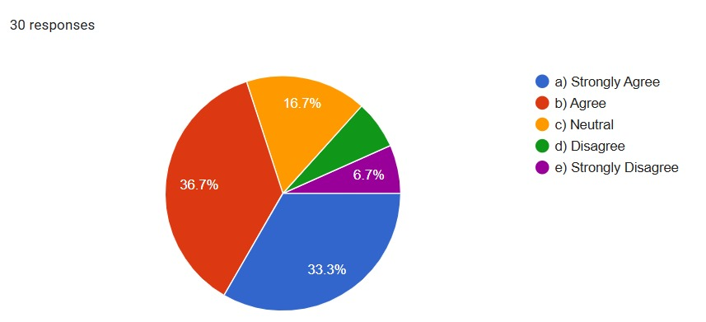

Fig 1. The number of people with order tracking support is highly valued.

The pie chart illustrates respondents' opinions on the value of order tracking support based on 30 responses. The largest portion, 36.7%, agreed that it is highly valued, followed by 33.3% who strongly agreed. Meanwhile, 16.7% were neutral, 6.7% disagreed, and a small 6.7% strongly disagreed. This indicates a generally positive perception of order tracking support.

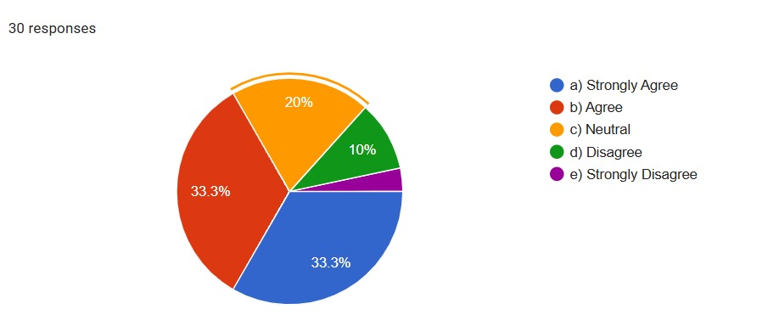
Fig. 2. No. of people with clear refund policies ensure reliability.

The pie chart depicts opinions on the reliability of clear refund policies, based on 30 responses. Equal proportions of 33.3% strongly agreed and agreed with the statement. Meanwhile, 20% remained neutral, 10% disagreed, and a small 3.3% strongly disagreed. This indicates that most respondents associate clear refund policies with reliability.

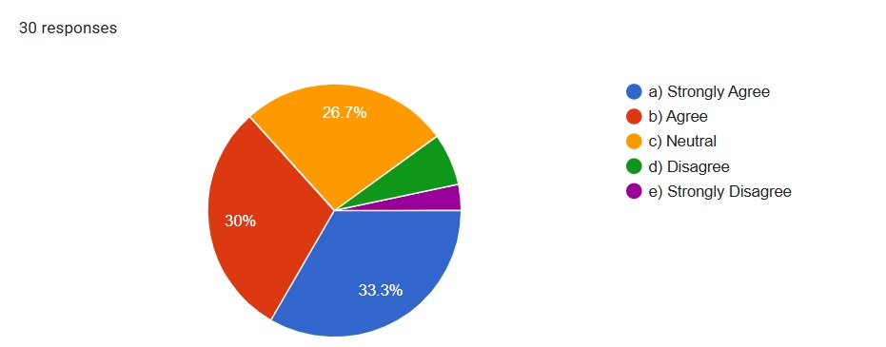

Fig. 3. No of people with Product videos improve the shopping experience.

The pie chart illustrates the responses to the statement "Product videos improve the shopping experience" based on 30 participants. A majority either strongly agreed (33.3%) or agreed (30%), indicating positive sentiment toward the statement. Meanwhile, 26.7% remained neutral, with minimal disagreement. This reflects a generally favourable perception of product videos in enhancing shopping experiences.

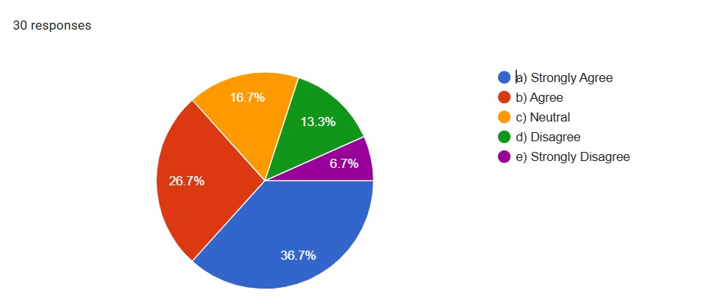
Fig 4. The number of people with Instant payment confirmations enhance user satisfaction.

The pie chart shows responses to "Instant payment confirmations enhance user satisfaction" from 30 participants. Most strongly agreed (36.7%) or agreed (26.7%), while 16.7% were neutral, and few disagreed (13.3%) or strongly disagreed (6.7%). Overall, feedback is largely positive.

Table 1. Customer Support Features

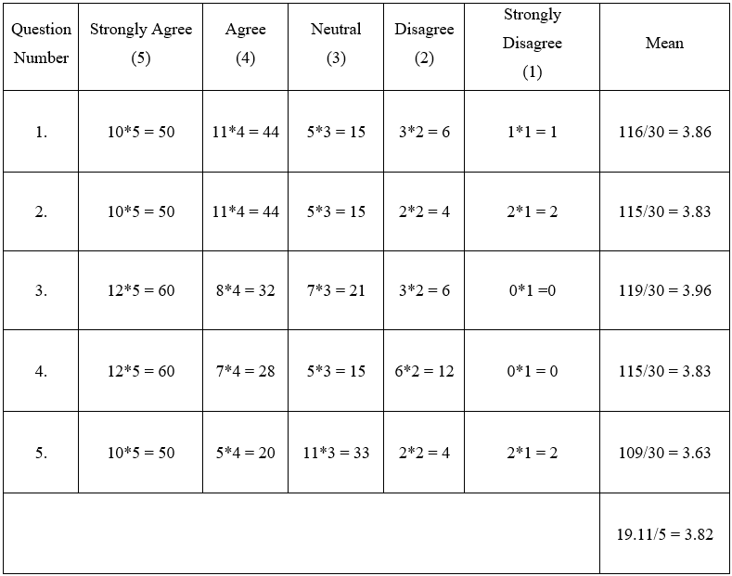

Table 2. Security and Trustworthiness

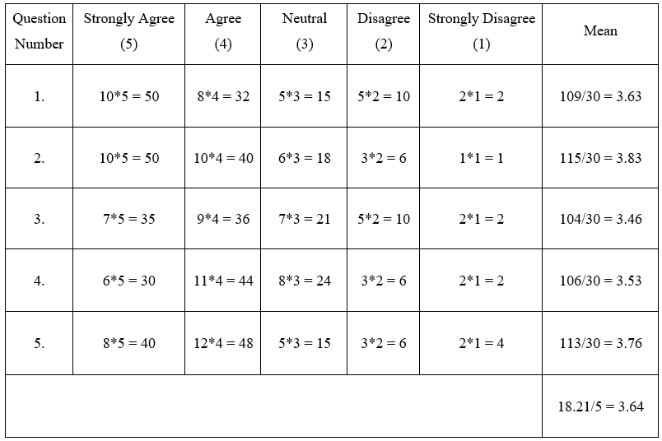

Table 3. Visual Content Quality

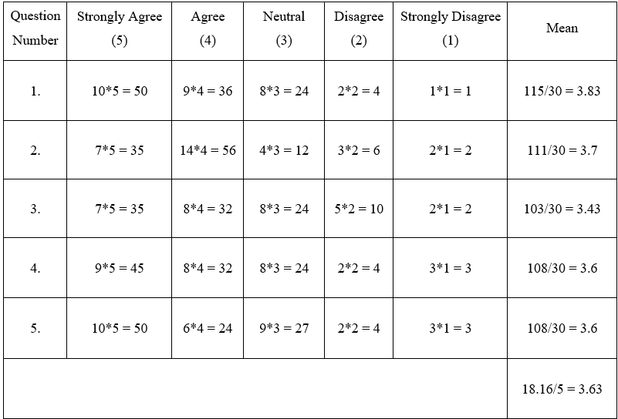

Table 4. Payment Gateway Integration

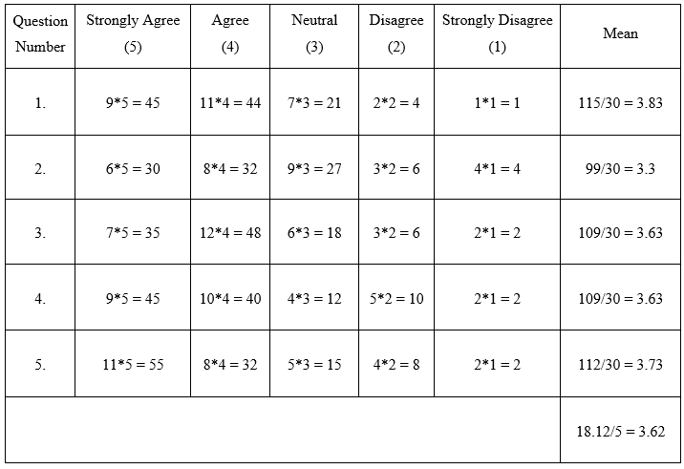

Bar Graph:

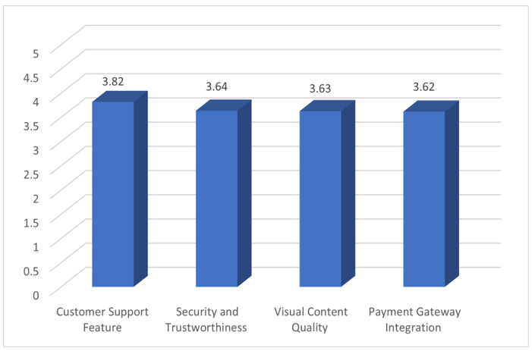

- Discussion
The analysis of strategic website design demonstrates its pivotal role in enhancing business growth by improving user satisfaction, trust, and engagement. Key features such as customer support, security, visual content quality, and payment gateway integration received positive feedback, though areas for improvement, particularly in security and content alignment, were identified. These findings underscore the importance of optimizing website design to meet user expectations and foster a seamless experience.
- Conclusion
Strategic website design plays a vital role in driving business growth by enhancing user satisfaction, building trust, and fostering customer engagement. The research highlights that key element such as customer support features, security measures, visual content quality, and seamless payment gateway integration significantly contribute to creating a positive user experience. Addressing the identified areas for improvement, such as enhancing security and refining visual aesthetics, can further optimize website performance. By prioritizing user-centric design and leveraging technological advancements, businesses can effectively strengthen their online presence and achieve sustained growth.

  - Limitation

This study is limited by the subjective nature of user feedback and the specific demographic sample. Future research could explore the impact of emerging technologies, such as AI-driven personalization and augmented reality, to further optimize website design strategies.

  - Implications for Business Growth

A well-designed website drives business growth by improving customer engagement, building trust, and enhancing the user experience. Prioritizing intuitive support features, robust security, visually appealing content, and seamless payment systems can lead to increased customer retention and higher conversion rates.
Acknowledgment
The team would like to extend sincere gratitude to Mr. AKIBUR RAHMAN KHAN, Lecturer, Faculty, Department of English, AIUB, for his invaluable guidance and support throughout the preparation of this report. His expertise and insightful feedback greatly contributed to enhancing the depth and quality of the work. Appreciation is also extended to all survey participants for their valuable time and input, which provided essential data for this research. Their contributions played a pivotal role in the successful completion of the report.
References
- S. M. Aladwani and P. C. Palvia, "Developing and validating an instrument for measuring user-perceived web quality," Information & Management, vol. 39, no. 6, pp. 467-476, May 2002.
Available: https://dl.acm.org/doi/10.1145/3426020.3426062 [Accessed: Jan. 17, 2025].

- G. L. Urban, F. Sultan, and W. J. Qualls, "Placing trust at the center of your internet strategy", MIT Sloan Management Review, vol. 42, no. 1, pp. 39-48, Fall 2000. Available: https://www.researchgate.net/publication/40964353_Placing_Trust_at_the_Center_of_Your_Internet_Strategy [Accessed: Jan. 17, 2025].

- R. T. Watson, L. F. Pitt, P. Berthon, and G. M. Zinkhan, "U-commerce: expanding the universe of marketing," Journal of the Academy of Marketing Science, vol. 30, no. 4, pp. 333-347, Oct. 2002.
Available: https://link.springer.com/article/10.1177/009207002236909 [Accessed: Jan. 17, 2025].

- L. Corritore, B. Kracher, and S. Wiedenbeck, "On-line trust: concepts, evolving themes, a model," International Journal of Human-Computer Studies, vol. 58, no. 6, pp. 737-758, Jun. 2003.
Available: https://dl.acm.org/doi/10.1016/S1071-5819(03)00041-7 [Accessed: Jan. 17, 2025].

